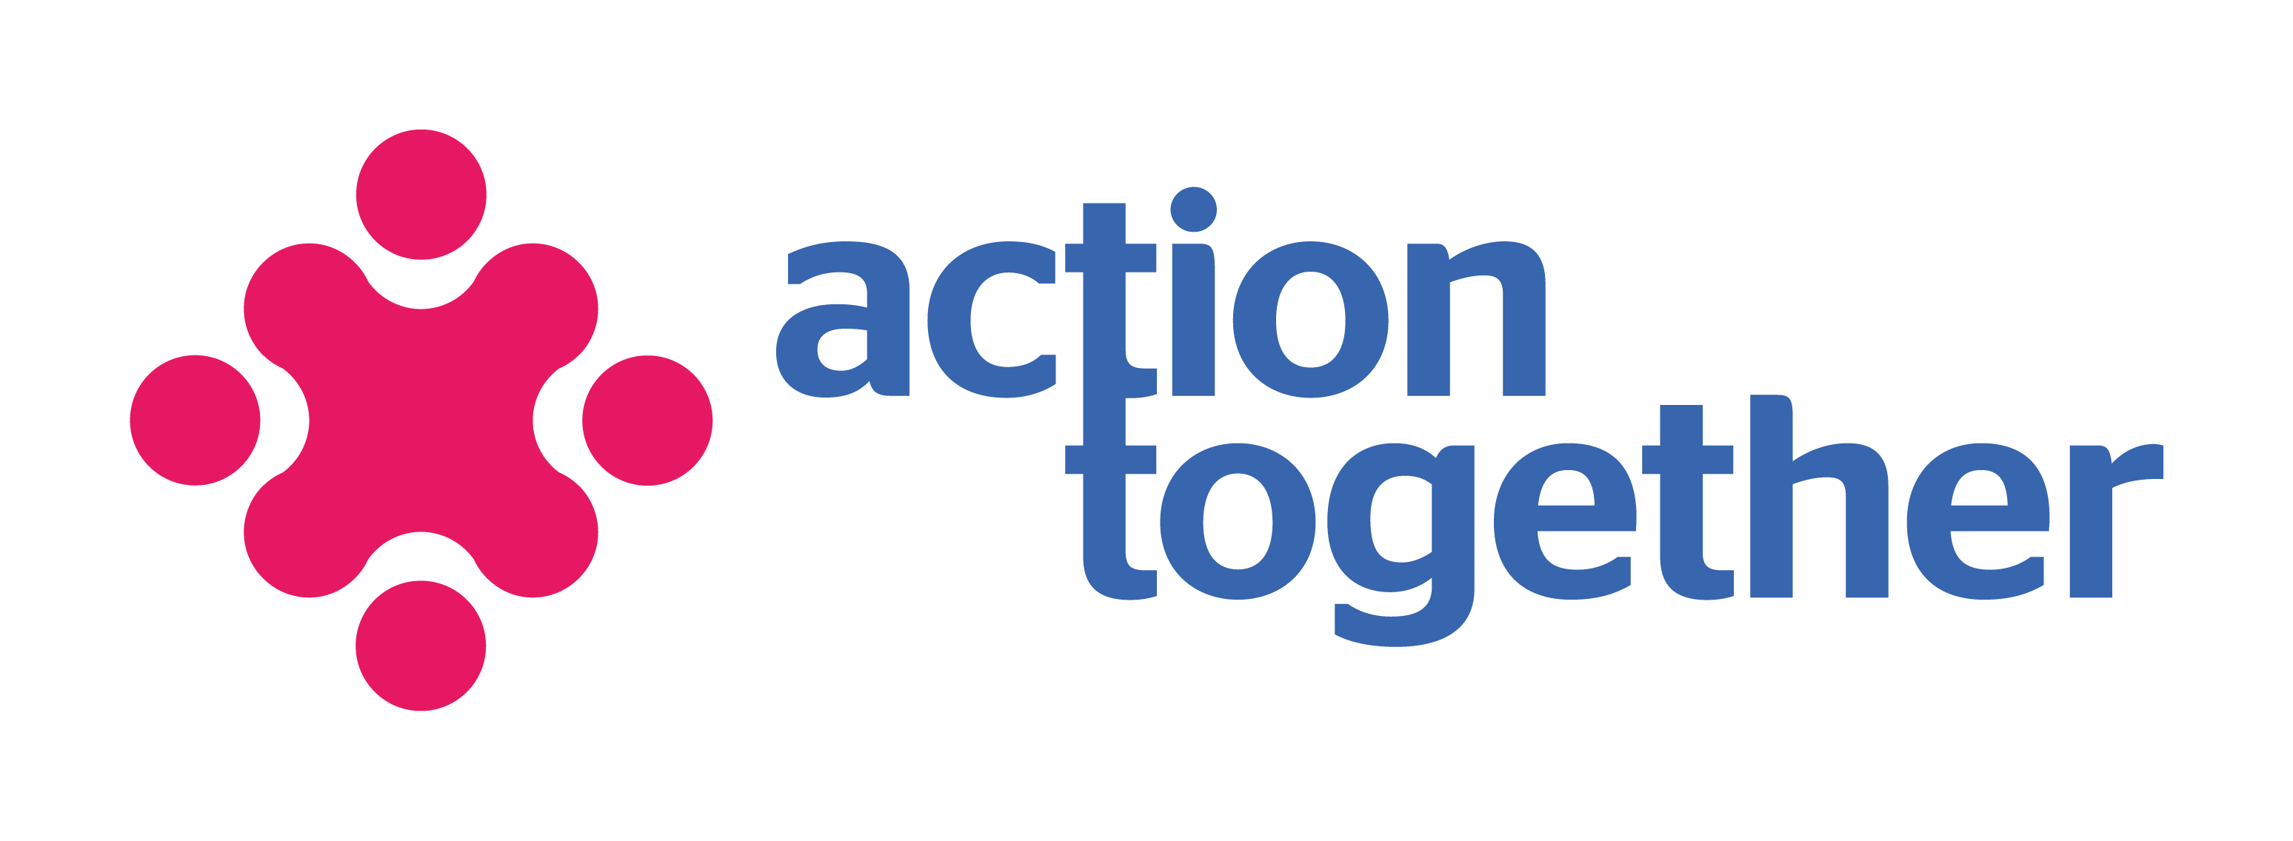



ROTARY CLUB of CHADDERTON & FAILSWORTH

COMMUNITY CASH AWARD
Working to support new and existing projects

We are seeking to fund inspiring ideas/actions which are about people and communities coming together to change things.

What could your community do with £1,000?

We are looking for groups and organisations (with constitutions) or people who just want to come together to make a difference in their own communities

Just use this form to tell us what you could do - it can be for anything as long as it addresses the priorities in your community.
If you need help with your idea or with the application, please contact Action Together’s Development Team on 0161 389 2345 or email development@actiontogether.org.uk

The deadline for applications are as follows:

- 30 September 2024 at 12 noon
- 30 November 2024 at 12 noon
- 30 March 2025 at 12 noon
- 30 June 2025 at 12noon

Please send your completed application form to:

Sharon McGladdery
Action Together
Medtia Place,
80 Union Street
Oldham OL1 1DJ

Or Email: sharon.mcgladdery@actiontogether.org.uk

Contact Details

Name of Organisation:

Address:

Post code:

Telephone number: Email:

Website:

The main contact person should be someone from your organisation who can discuss the application. Please give a second contact in case the main contact is unavailable.

 | Main contact person | Second contact person
Name
Position
Telephone Number
(if different from above)
Contact email
Best time to contact

When did your organisation start?
Where in the Oldham borough is most of your work carried out? (For example: Failsworth, Uppermill, Coldhurst)
Do you have a signed constitution? | Yes / No
Do you have a group bank account? | Yes / No
Does your project involve work with children, young people under the age of 18 or vulnerable adults? | Yes / No
If yes, do you have safeguarding policies in place that are appropriate to your organisation’s work and the project you are asking us to fund? | Yes / No
Is this money for a new activity, or to continue funding an existing activity? | New / Existing
Have you raised anything so far? | £
How much are you requesting from Rotary Club of Chadderton & Failsworth | £
If you are successful with this funding, will you be prepared to give a presentation/talk to the Rotary on your project? | Yes / No
Please tell us:
- Why is your project needed?
- What you would spend this grant on?
- How will people know about your project and
- How will they get involved?
- Please give approximate dates for any activities involved.

Please provide a breakdown of activity costs

Item | Cost
TOTAL

If you receive a grant, how will you be able to show us the difference that has been made?

How will you share and spread information about your idea/project/activity with other people and groups if you are successful?

Declaration

It is essential you understand and agree to sign up to the following statements.

We confirm that the information contained in this application is correct and that we are authorised by the group to accept these conditions on their behalf.

We agree to visit the Rotary Club of Chadderton & Failsworth and feedback on the success of our project.

If the information in the application changes in any way, I will inform the Rotary Club of Chadderton & Failsworth.

If successful we will not use the grant for any other purpose other than that specified on the grant award letter without first contacting the Rotary Club of Chadderton & Failsworth to seek authorisation.

We accept that we may be asked to return this grant should the Rotary Club of Chadderton & Failsworth deem the evidence for spend provided by us in our End of Grant report unsatisfactory.

If the main contact leaves the group or can no longer fulfill their responsibilities, or someone takes over responsibility for the grant on behalf of the group, we will inform the Rotary Club of Chadderton & Failsworth immediately.

We agree for the Rotary Club of Chadderton & Failsworth and Action Together to use the group’s name and photographs for promotional purposes if our request for funding is successful.

Main Contact Person  (Person completing this application) |  | Second Contact Person
Signature |  | Signature
Full Name |  | Full Name
Position |  | Position
Date |  | Date
I confirm that I have read this  application ◻ |  | I confirm that I have read this application ◻

